**INTRODUCTION**

Since the divergence of hominins from the genus *Pan* ~5–7 Ma, our lineage has undergone a massive expansion in brain size, such that modern humans have brains that are over three times larger than those of the other great apes*,* our closest extant relatives (Dunbar, 1993; Holloway, 2008; Sherwood et al., 2008; Klein, 2009) . However this phenomenon is not unique to hominins, as evolutionary increases in brain size have also been demonstrated in non-human Primates, Carnivora, Artiodactyla and birds (Lefebvre et al., 2004; Shultz and Dunbar, 2010).

While the precise causes of evolutionary brain enlargement remain unclear, many hypotheses revolve around enhanced cognitive flexibility (Lefebvre et al., 2004; Sol et al., 2005; Krubitzer, 2009; Sol, 2009). Organisms may evolve larger brain size as an adaptation to more efficiently solve novel problems and thus flexibly respond to changes in their dietary niche (Broadhurst et al., 1998; Carmody and Wrangham, 2010) or to navigate complex social networks (Dunbar, 1998; Shultz and Dunbar, 2007, 2010). Large-scale changes in climate have also been proposed as a driver of brain evolution. However, which aspects of climatic change are most significant for brain evolution is a matter of ongoing debate, particularly in the field of human origins (Behrensmeyer, 2006; Faith and Behrensmeyer, 2013). Trend-based hypotheses implicate long-term directional changes in aspects of the climate, such as temperature and/or aridity as the primary drivers of evolution (e.g. savannah hypothesis, aridity hypothesis, and aspects of turnover pulse hypothesis) (Vrba, 1994; deMenocal, 2004; Domínguez-Rodrigo, 2014). Alternatively, variability-based hypotheses implicate increasingly severe climatic fluctuations (e.g. variability selection hypothesis, variability pulse hypothesis) (Potts, 1996, 1998a; Bobe et al., 2002; Trauth et al., 2007, 2010, Maslin et al., 2014, 2015). More specifically, variability-based hypotheses posit that increases in the amplitude and periodicity of global environmental fluctuations may induce extinction, migration, and in some instances, influence some species to become more versatile and thus to more effectively adapt to rapidly changing environments. According to this third scenario, hominins responded to an increased demand for versatility by evolving larger brains capable of enhanced behavioral plasticity (Potts, 2012). Lastly, some have suggested the rapidity at which climate change occurs may be a catalyst of evolution, here referred to as rate-based hypotheses (e.g. turnover pulse hypothesis) (Vrba, 1993, 1995, 1996).

While often conceptualized as mutually exclusive, there is in fact considerable overlap among these hypotheses. Changes in trend, variability, and rate are highly interactive aspects of the global climate that can in turn have complex downstream effects on environment at the level of continents, regions, local habitats, and communities of organisms (Zachos et al., 2001; Maslin and Christensen, 2007). Therefore, it seems more appropriate to test these hypotheses within a single comprehensive model.

While there have been numerous claims of a relationship between hominin brain size and climate (Vrba, 1994, 1995, 1996, Potts, 1998b, 2012; Shultz and Maslin, 2013; Maslin et al., 2015) only a few studies have attempted to statistically test this relationship. Ash & Gallup (2007) examined the relationship between brain evolution and climate, finding that both global cooling trends and global temperature variability significantly correlated with increasing hominin cranial capacity (CC) (n=109 specimens) over the last 2 Ma. In a subsequent multivariate analysis of the Ash & Gallup (2007) dataset, Bailey & Geary (2009) found that climatic trends towards global cooling and increased variability as well as other predictors of CC (e.g. estimated population density, parasitic load) predicted hominin CC. Despite these efforts the conclusions that can be drawn from these studies have some notable limitations. First, they did not include measures of the rate or speed of climatic change as factors that might also be associated with brain size evolution. Second, and perhaps more importantly, they did not account for the confounding effects of temporal autocorrelation in time-series data (such as brain size change over time vs. climatic change over time), leaving open the possibility that previous associations between hominin brain size and climate are spurious. Fortunately, there is a wide body of research devoted towards accounting for such statistical complications.

The use of time series data is common in many fields, including ecology. Non-stationarity of data (i.e. data showing a directional trend over time) may result in temporal autocorrelation, or the tendency of a dataset to correlate with itself over points in time (Chatfield, 2004). If a correlation is found between two non-stationary time-series, this relationship could be spurious in that the two datasets are in fact not causally related to one another. Just one of numerous examples of this error is the relationship between the westward tectonic movement of North America and the global isotope record (Alroy et al., 2000). Both datasets show directional change over time (i.e. are non-stationary) and thus show strong cross-correlations despite being causally unrelated to one another. This renders any interpretations of causality between trended time series as highly suspect, as temporal autocorrelation can often cause even random walks to produce significant cross-correlations. Alroy and colleagues (2000) discuss the pitfalls of failing to account for the effects of non-stationarity in the context of relating oxygen isotope time series to biotic data (e.g. Cenozoic mammalian diversity and body mass over time). This clearly demonstrates the potential for spurious correlations (and thus unfounded conclusions) that can come about when correlating time-series data with directional trends. The authors note that while it is tempting to observe two strong trends over time and declare that they are causally related, it is far more informative to observe how the variables change between time intervals, and to ask whether these changes are correlated. Correlations in these “*blow-by-blow, interval-by-interval”* differences in time series data are much more informative than correlations in trended time series*.*

Later work represented a significant methodological advancement over previous attempts to test for brain-climate relationships in hominins in that, importantly, efforts were made to guard against the potential effects of non-stationarity (Shultz et al., 2012; Shultz and Maslin, 2013). Using a more appropriate statistical methodology, Shultz, Nelson & Dunbar (2012) found little evidence for interactions between global climate and hominin brain size, contrasting with previous findings (Ash and Gallup Jr., 2007; Bailey and Geary, 2009). Interestingly, there is other evidence to suggest that regional climate in the East African Rift System did influence hominin brain evolution during certain time periods (Shultz and Maslin, 2013). However, in all previous investigations, (Ash and Gallup Jr., 2007; Bailey and Geary, 2009; Shultz et al., 2012; Shultz and Maslin, 2013) CCs of non-hominin mammalian taxa were not included in the sample. Employing a broader comparative approach would allow one to determine whether climatic variables are related to brain size variation as a general principle of mammalian evolution outside of hominins. The paleontological record demonstrates that brain size has increased across many different taxa (Jerison, 1973; Montgomery et al., 2010; Boddy et al., 2012) but it remains to be determined whether these increases relate to climatic shifts.

The first goal of the present study was to identify which mammalian taxa (if any) display evidence for evolutionary increases in brain size over time. This was assessed using two independent sources of CC data: fossil CCs and ancestral state reconstructions derived from extant mammalian CCs. The fossil record is limited in a number of ways, including the error associated with various dating techniques (Ludwig and Renne, 2000) and the possibility that the earliest representatives of phylogenetic lineages have not yet been discovered. The fragmentary nature of many fossils often make taxonomic placement of these specimens challenging or sometimes inconclusive. Furthermore, taphonomic processes can potentially deform the endocranial cavity of the skull, thus affecting the ultimate estimate of CC (Holloway, 2008). Thus uncertainties in dating and morphological estimates in the fossil record pose some notable sources of error.

We used ancestral state reconstruction as a complementary method to computationally infer the most probable state of a common ancestor shared between two or more species. While this method avoids some of the limitations of the fossil record, it possesses several of its own inherent sources of error and assumptions. Notably, it inherits errors associated with the estimation of molecular divergence dates and species relationships from the chosen phylogenetic tree. Despite this, in the way we employ it here ancestral state reconstruction has the advantage of being derived from precise estimates of CC as they are directly measured from an extant sample of mammalian specimens. Here we employ both fossil and ancestral CCs in our analyses under the supposition that concurrence of results between both methods increases confidence in results showing a relationship between CC and climate variables.

The second goal was to test for potential relationships between changes in CC and changes in global climate, using the deep-sea oxygen isotope record as a proxy. In order to address the possibility of multiple climatic factors simultaneously influencing brain evolution, we used multiple regression models with CC as the response variable and three different measures of climatic change as the predictor variables. Each climatic measure was intended to represent a different climatic hypothesis (Fig. 1):

1) *Trend*: This measure represents directional change-based hypotheses (e.g. deMenocal’s (2004) aridity hypothesis ), which predict that trends towards colder temperatures and increased aridity correlate with increased CC in hominins. This was quantified as mean oxygen isotope values in a given time interval.

2) *Variability*: This measure represents variability-based hypotheses (e.g. Potts’ (1996, 1998a, 2012, 2013) variability selection hypothesis) which predict that increased fluctuations in global temperature and aridity lead to increased CC in hominins. This was quantified as standard deviation of oxygen isotope values in a given time interval.

3) *Rate*: This measure draws from aspects in both trend- and variability-based hypotheses as well as the rapid changes envisioned in turnover-pulse hypothesis (Vrba, 1993, 1996). The rate-based hypothesis proposed here predicts that increases in the rate of change in global temperature and aridity lead to increases in CC. This was quantified as the slope of the linear regression of oxygen isotope values in a given time interval.

The third goal of this study was to assess whether accounting for non-stationarity has any effects on the relationship between CC and global climate using an alternative statistical method to Shultz, Nelson & Dunbar (2012).

Each taxon has its own evolutionary history, array of ecological niches, and distribution across habitats, which can influence how they respond to a given environmental pressure. Thus we predicted that each taxon may be differentially affected by various aspects of global climatic shifts over time (i.e. trend, variability, rate), if at all.

**MATERIALS AND METHODS**

The R script and all datasets necessary to replicate the analyses and figures presented in this study are provided in the Supplementary Appendix.

***Fossil CC Data***

CCs for 227 mammalian fossil species from six different taxa (Artiodactyla (*n* = 20 species), Carnivora (*n* = 129), Cetacea (*n* = 26), Perissodactyla (*n* = 14), and non-hominin Primates (*n* = 19)) were extracted from the Shultz & Dunbar supplementary dataset (2010). For the hominin sample, CC and date (in Ma) for 189 individual specimens were extracted from Shultz, Nelson & Dunbar (2012), Schoenemann (2013), and Berger et al. (2010). These individuals were fit into a scheme of 19 different hominin species including: *Ardipithecus ramidus* (n = 1), *Australopithecus afarensis* (n = 5), *Australopithecus africanus* (n = 8), *Australopithecus garhi* (n = 1), *Australopithecus sediba* (n = 1), *Kenyanthropus platyops* (n = 1), *Homo habilis* (n = 10), *Homo rudolfensis* (n = 3), *Homo ergaster* (n = 6), *Homo georgicus* (*n* = 3), *Homo erectus* (n = 33), *Homo floresiensis* (n = 1), *Homo antecessor* (n = 3), *Homo heidelbergensis* (n = 21), *Homo neanderthalensis* (n = 27), *Homo sapiens* (n = 58), and the robust australopiths *Paranthropus aethiopicus* (n = 1), *Paranthropus boisei* (n = 6), and *Paranthropus robustus* (n = 3). Species averages were calculated when multiple specimens per species were available.

Each specimen was assigned an associated date (Ma) corresponding to the First Appearance Datum (FAD) of that fossil species as an approximation of its emergence. We assume that any error associated with these measures was equally distributed across all taxa (Shultz and Dunbar, 2010).

While a complete set of analyses investigating CC, body size, encephalization quotient (EQ) (Martin, 1981, 1984) and their interrelated dynamics would be worthwhile, reliable estimates of body mass in fossil taxa are relatively sparse. In the Shultz & Dunbar (2010) dataset, fossil body mass was often estimated based on cranial orbit measurements. However recent evidence (Elliott et al., 2014) suggests that orbit dimensions are not reliable estimators of hominin body mass, as previously suggested (Aiello and Wood, 1994). This issue is further compounded when comparing specimens across multiple mammalian taxa with highly variable relationships between orbit dimensions and overall body size. Furthermore, some evidence suggests that total CC is the a better predictor than EQ of measures of intelligence (Deaner et al., 2007) and the ability to adapt to novel environments (Deaner et al., 2007; Sol et al., 2008).

***Ancestral CC Data***

To provide an independent source of CC data, ancestral state reconstructions were calculated via Restricted Maximum Likelihood (REML) estimation using the Analysis of Phylogenetics and Evolution (APE) package (Paradis et al., 2004) in R version 3.2.3 (R Development Core Team, 2015). The REML method assumes species diverge according to Brownian motion and takes into account branch length. It has proven capable of reliably generating reconstructions of biological measurements (e.g. brain size) that can be cross-validated with the fossil record. Previous investigations have utilized this method to reconstruct the brain size of ancestral Primates (Montgomery et al., 2010; Boddy et al., 2012), Carnivora (Finarelli and Flynn, 2007), Cetacea (Montgomery et al., 2013) and other mammalian taxa (Boddy et al., 2012).

Extant CCs tip data for Artiodactlya (*n* = 25), Carnivora (*n* = 157), and Cetacea (*n* = 32) were taken from the Shultz & Dunbar dataset (2010) while Primate data (*n* = 76) were taken from the Boddy et al. dataset (2012). The authors acknowledge that Cetacea and Artiodactyla represent the monophyletic clade known as Cetartiodactyla. However for the purposes of this study the clade is subdivided due to their drastically different ecologies, which are likely to be differently affected by global climatic changes. Tree data were derived from the Bininda-Emonds et al. (2007) mammalian supertree. Polytomies were resolved by assigning a branch length of 0.1 Ma in these instances, which sufficiently differentiated a given shared node into several independent nodes while minimizing the effect of altering the branch lengths on the ancestral state reconstruction results. This alteration proved necessary, as branch lengths of 0 resulted in computational errors in the REML calculations. The REML produced 289 total ancestral CCs with the following distribution by taxon: Artiodactlya (*n* = 22), Carnivora (*n* = 156), Cetacea (*n* = 31), Perissodactyla (*n* = 8), Primates (*n* = 72).

***Climatic Data***

The deep-sea oxygen isotope record serves as a proxy for mean ocean temperature, which tracks global temperature over long periods of time. A high-resolution oxygen-isotope (∂18O) record calibrated to the standard geomagnetic polarity time scale (GPTS) were extracted from the literature (Zachos et al., 2001). These data were originally culled from deep-sea core isotope records from 40 different sites around the world spanning from present day to 65Ma. Since isotopic values do not vary significantly by site, it is appropriate to use the combined dataset as a proxy for global climate change. This record provides a proxy for global temperature shifts that can in turn affect various regions through a network of complex environmental interactions.

Measures of mean, standard deviation (sd) and slope of the ∂18O record were calculated for a given span of time, referred to as intervals (Fig. 2). All analyses were repeated separately for each interval: 1My, 400Ky, and 200Ky. For example, if a species appeared at 2Ma, that species’ CC would be correlated with each climatic measure (i.e. mean, sd and slope) over the course of 2.0–3.0Ma (1My interval), 2.0–2.4Ma (400k interval), and 2.0–2.2Ma (200Ky interval) (Fig. 3). The 400Ky and 200Ky intervals correspond to periodic cycles of the planet’s orbit, which have been previously suggested to be an important climatic factors may have influenced hominin evolution (Potts, 1998a; Zachos et al., 2001). 1Ma intervals were also investigated in an attempt to capture a large number of climatic events per unit, which may be related gradual long-term evolutionary changes in certain taxa (Foley, 1994).

**Analyses of *CC vs. Time***

First, Ordinary Least Squares (OLS) linear regression were performed in R using the lm function in the *stats* package (R Development Core Team, 2015). CC was used as the response variable while time (in terms of Ma) was used as the predictor variable, first with all taxa grouped together and then divided into five separate taxa to elucidate the relative contribution of each taxon to any potential overall mammalian patterns. These analyses were repeated separately for the fossil and ancestral reconstruction CC datasets.

***Analyses of CC vs. Climate***

Next, multiple regressions analyses were performed also using the lm function in R (R Development Core Team, 2015). Again, CC was the response variable but the previously calculated climatic measures were used as predictor covariates (*CC ~ mean + sd + slope*). All analyses were conducted separately using the fossil CC and then ancestral reconstruction CC datasets (source code provided in SI).

There are several well-established methods that can statistically account for non-stationarity (Chatfield, 2004). The goal of these methods is to convert the non-stationary (trended) time series into a stationary (detrended) time series, or a time series that does not show a directional trend over time. The effect of detrending a previous trended dataset is illustrated in Figure 4. A commonly used method is to calculate the first differences of the original time series (Alroy et al., 2000). The corrected (detrended) time series are computed as follows: *y′t = yt - yt-1*, where *yt* and *yt-1* are temporally adjacent data points (e.g. oxygen isotope values) from which a differenced data point (*y′t* ) is calculated. Note that the detrended time series of first differences will be of length *n -1* where n is the length of the original pre-detrended time series. Thus, in the new detrended time series each point reflects the difference between adjacent time bins. The resulting detrended time series can be used in subsequent analyses with other detrended time series. By employing this methodology one can be much more confident that any observed cross-correlations are meaningful relationships and not merely misleading coincidences.

To account for temporal autocorrelation in our study, we used the aforementioned methodology to detrend both the CC data and the oxygen isotope data by calculating the magnitude of difference between any two adjacent data points in time (Alroy et al., 2000) (Fig. 4). However, in order to do this some of the data had to be averaged as some specimens shared the same points in time. For example, if fossil species A (with a CC of 400mL) and B (with a CC of 500mL) both appeared at 22.1Ma, their CCs would be averaged to get a CC of 450mL for time point 22.1Ma. This especially reduced the number of observations in the analyses of fossil CC (from 227 to 71 across all taxa) likely due to the fact that many specimens often come from single paleontological sites and/or stratigraphic contexts that are associated with the same geological age. This contrasts with computationally reconstructed ancestors (which only dropped from 289 to 237) whose associated dates are ultimately derived from molecular divergence dates, offering a much wider variety of possible time points. Nevertheless, multiple species averaged into a single time point will still be more likely to provide a more accurate estimate of its respective taxon’s typical CC than a single species from that taxon.

***Concordance & Evidence Scores***

In order to summarize the findings of this study, Concordance Scores (how often results of fossil and ancestral datasets concurred) and Evidence Scores (how much evidence there was overall for CC being influenced by climate) were calculated for each taxon matched for time interval (1My, 400Ky, 200Ky) and climatic predictor variable (Trend, Variability, Rate, or the multivariate model) (Table 1). In the Significance columns, “Y” denotes that the multiple regression analysis revealed a significant relationship between CC and the given climatic variable within a given taxon (e.g. All Taxa, Artiodactyla, Carnivora, etc.) within a given interval (e.g. 1My, 400Ky, 200Ky) using either non-detrended or detrended datasets, whereas “N” denotes a lack of significant relationship (p > 0.05). In the Concordance columns, “1” denotes that analyses using both the fossil and the ancestral CC yielded similar results (either both “Y or both “N”), whereas “0” denotes that there was a discrepancy between the results of these datasets. In the Results Summary column, a Concordance Score was calculated by taking the number of concordant values (“1”) and dividing over the total number of analyses (“1” or “0”) within a given taxon within a given interval. Evidence Scores were calculated by taking the number of detrended analyses that yielded a significant relationship between CC and a given climatic variable (“Y”) and dividing by the total number of detrended analyses (“Y” or “N”) within a given taxon (multiplied by 100 to put in terms of %). Evidence scores did not include non-detrended results due to the effects of temporal autocorrelation discussed above.

**RESULTS**

***CC vs. Time***

Using the fossil CC dataset (Fig. 5A), when all mammalian taxa were analyzed as one group there was a small but significant trend of increasing CC as time approached the present (Adjusted R2 (aR2) = 0.193, coefficient estimate (ce) = -0.047, p = 0.000). When separated by taxon, most groups showed evidence of increasing CC over time, including Artiodactyla (aR2 = 0.404, ce = -0.084, p = 0.002), Carnivora (aR2 = 0.139, ce = -0.038, p = 0.000), Perissodactyla (aR2 = 0.337, ce = -0.037, p = 0.018), and Primates (aR2 = 0.297, ce = -0.057, p = 0.010). Hominins were treated as their own separate group to allow for comparisons with other mammalian taxa, and displayed the most dramatic increase in CC over time (aR2 = 0.493, ce = -0.304, p = 0.001). In order to explore the effect of increased sample size on the results, these data were reanalyzed with the hominin CC dataset broken into individual specimens, thus increasing the sample size from 13 species to 91 individuals, yielding an even stronger trend of increasing CC over time (aR2 = 0.834, ce = -0.429, p = 0.000) (see full results in Table S1).

Using the ancestral reconstruction CC dataset (Fig. 5B), when all taxa were analyzed as one group, there was a small but significant decrease in CC over time (aR2 = 0.049, ce = 0.028, p = 0.000). No individual mammalian taxa displayed evidence of change over time, except for Primates, which showed an increase in CC as time approached the present (aR2 = 0.074, ce = -0.024, p = 0.012). As mentioned above, it was not possible to include hominins in this type of analysis (see full results in Table S2).

***CC vs. Climate***

Multiple regression analyses of non-detrended fossil CC and climatic data were first conducted. These showed that CC of the pooled sample from all fossil mammalian taxa (*n* = 222) was significantly predicted by the climatic model at all three time intervals (1My, 400Ky, & 200Ky) (aR2 = 0.426–0.458, p < 0.001); Trend was the only significant predictor variable at all three intervals (ce = 2.141–2.292, p < 0.001). Artiodactyla CC was only significantly predicted by the climatic model at the 400Ky interval (aR2 = 0.551, p < 0.05) in which Variability was the only significant predictor variable (ce = -0.454, p < 0.05). Carnivora CC was predicted by the climatic model at all three intervals (aR2 = 0.252–0.288, p < 0.01) in which Trend was the only significant predictor variable in each interval (ce = 1.542–1.645, p < 0.002). Perissodactyla CC was only predicted by the climatic model at the 400Ky interval (aR2 = 0.672, p < 0.05) in which Trend was the only significant predictor variable (ce = 1.253, p < 0.05). Species-averaged hominin CC was predicted by the climatic model at all three time intervals (aR2 = 0.365–0.488, p < 0.05) but no single climatic predictor variable significantly contributed this relationship on its own (p > 0.05). Individualized hominin CC was even more strongly predicted by the climatic model (aR2 = 0.759–0.799, p < 0.001) in which both Trend (ce = 1.312–1.599, p < 0.01) and Variability (ce = 0.499–0.793, p < 0.01) were significant predictors at all time intervals. Neither Cetacea CC nor Primate CC were predicted by the climatic model at any interval (p > 0.05) (see Table S3A).

Results differed considerably when these analyses were rerun after detrending the fossil CC and climatic data sets. Consistent with the non-detrended results, neither Cetacea nor Primate CC were predicted by the climatic models (p > 0.05). Additionally, CC of all taxa grouped together, as well as Carnivora, Primates, hominins and individualized hominins were not significantly predicted by the climatic model at any time interval (p > 0.05). This is particularly noteworthy in individualized hominins, which showed a strong CC-climate relationship before detrending the data. However, detrending the data did not eliminate all significant results as Perissodactyla CC was predicted by the climatic model (aR2 = 0.481–0.711, p < 0.05) (see Table S3B).

Next, we performed the analyses described above with ancestral reconstruction of CCs, first using non-detrended CC and climatic data. Ancestral CC of all taxa grouped together was not significantly predicted by the climatic model at any time interval (p > 0.05). This was also true of Artiodactyla, Cetacea, and Perissodactyla CC (p > 0.05). Carnivora CC was predicted by the climatic model only at the 1My interval (aR2 = 0.038, p < 0.05) in which Rate was the only significant predictor variable (ce = -0.159, p < 0.05). Primate CC was predicted by the climatic model at the 400Ky and 200Ky intervals (aR2 = 0.089–0.104, p < 0.05) in which Variability was a significant predictor at 400Ky (ce = -0.227, p < 0.05) and Trend was a significant predictor at 200Ky (ce = 0.265, p < 0.05) (see Table S4A).

After detrending the data, ancestral reconstruction of CCs showed a very different pattern of relationships with the climate variables. CC of all taxa grouped together was predicted by the climatic model at all time intervals (aR2 = 47.997–63.296, p < 0.001) in which Trend was a significant predictor variable at all three intervals (ce = 2.753–2.942, p < 0.001), Variability was a significant predictor at the 200Ky interval (ce = 0.31, p < 0.05), and Rate was a significant predictor at 400Ky (ce = 0.274, p < 0.01). Carnivora CC was predicted by the climatic model at only the 1My interval (aR2 = 2.824, p < 0.05) in which Rate was a significant predictor variable (ce = -0.274, p < 0.01). Artiodactlya, Cetacea, Perissodactyla, and Primate CC were not significantly predicted by the climatic model at any interval (p > 0.05) (see Table S4B).

***Concordance & Evidence Scores***

All taxa grouped together yielded a Concordance Score of 58.33, meaning 58.33% of results of fossil vs. ancestral analyses came to the same conclusion regarding whether or not there was evidence of a relationship between changes in CC and climate over time (Table 1). In descending order, Concordance Score of each taxon were as follows: Cetacea (100), Artiodactyla (91.67), Perissodactyla (66.67), Primates (58.33), Carnivora (45.83). All taxa grouped together yielded an Evidence Score of 37.50, meaning 37.50% of detrended analyses (using fossil or ancestral CC) showed a significant relationship between CC and climate. In descending order, Evidence Scores for each taxon were as follows: Perissodactyla (22.25), Carnivora (12.50), Primates (4.17), Artiodactyla (0.00), Cetacea (0.00), hominins (0.00), individualized hominins (0.00).

**DISCUSSION**

In the fossil dataset, it was found that across mammals in general, there was a trend towards increased brain size over time. Subdividing the sample by taxon revealed that many, but not all, mammalian lineages contributed to this overall pattern. This is consistent with previous demonstrations of increasing absolute or relative brain size over time in the fossil record of Artiodactyla (Jerison, 1970, 1973), Carnivora (Jerison, 1970, 1973, Finarelli and Flynn, 2007, 2009), Perissodactyla (Edinger, 1948; Jerison, 1970), Primates (Holloway, 1968; Jerison, 1973), and hominins (Shultz et al., 2012; Schoenemann and Begun, 2013) (see also Shultz & Dunbar (2010) for an inter-order comparison). Cetacea were the notable exception to this pattern of increasing brain size, as their average brain size has remained consistently large since their emergence. The contrast of our results with those of previous studies that reported directional increases in Cetacean brain (Marino et al., 2004; Boddy et al., 2012; Montgomery et al., 2013) likely stems from differences in samples and methodology. It should, however, be noted that different taxa of mammals occupy different, partially overlapping time periods over the last 65 My. Some taxa have existed much longer than others and thus span a much larger portion of the oxygen isotope record. This means that some taxa would have experienced a wider range of selective pressures, some of which could influence evolutionary shifts, speciation events, and extinctions.

Hominins occupy a particularly short and recent period of time (the last ~5–7 Ma). This is, of course, partly due to the fact that they represent a taxonomic tribe rather than an order like most of the other taxa investigated here. Despite having only existed during a relatively brief time, hominins have undergone remarkable evolutionary increases in brain size (Fig. 3 & Fig. 5A) which may have been in response to greater selective pressures for cognitively-mediated adaptability and problem solving in novel environments (Sol et al., 2005, 2008). This rapid increase in brain mass drastically deviates from the allometrically predicted brain mass of a primate of modern human body size and likely relates to many enhanced cognitive capacities including tool manufacture, complex social cognition, and language (Deacon, 2000; Passingham, 2008; Sherwood et al., 2008; Stout and Chaminade, 2012).

The results using ancestral reconstructions of CCs showed a rather different pattern. Instead of an overall increase in CC over time, there was an opposite pattern of decreasing CC over time. When this was investigated at the level of separate taxa, it was found that no taxon showed any significant change in CC over time except Primates, which showed a slight increase (Fig. S2). This seemingly contradictory pattern is at least partially explained by the high rate of speciation in smaller-brained Carnivora (relative to other larger-bodied taxa) over the last ~20 Ma (Fig. S2). Indeed, when Carnivora are removed from the total sample of mammals, the size effect of the negative trend is reduced, though still significant (ce = 0.024, p = 0.009). Another contributing factor to the discrepancy between the fossil and the ancestral CC results was that it was not possible to include hominins in the ancestral reconstruction analyses, as *Homo sapiens* are the sole extant representatives of the hominin lineage. The lack of a hominin ancestral CC sample further suppressed the more recent average CC when all taxa were grouped together. This is evidenced by the fact that the effect of increasing brain size over time was reduced (ce = -0.035, p = 0.000) when hominins are removed from the grouped fossil taxa analysis.

A number of hypotheses have proposed climatic changes as a driver of brain evolution (Potts, 1996, 1998b, 2012, 2013; Vrba, 1996; deMenocal, 2004). Using a statistically rigorous approach across a taxonomically diverse sample, this study tested these hypotheses and found evidence that in some mammalian taxa (Perissodactyla, Carnivora, and non-hominin Primates) brain size evolution has indeed been influenced by global climate. However it should be noted that the relationship was not always positive. In some cases, an increase in brain size was associated with a decrease in climatic Rate of change (e.g. detrended fossil Perissodactyla CC at the 1 My interval) or an increase in Variability (e.g. detrended all grouped fossil taxa CC at the 400 Ky interval) (see Table 3SB).

Fossil and ancestral CC results did not always concur, illustrating the importance of using multiple independent sources of data to establish levels of confidence in one’s interpretation of evolutionary history. All three climatic variables (Trend, Rate, and Variability) were shown to contribute in varying degrees and combinations depending on the CC dataset, taxa, and time interval investigated. However, once the time-series data had been properly detrended, this study provided no evidence for a relationship between brain size and climate in several taxa, most notably, hominins (Table 1 & S3).

Based on the fossil record data, it appears that hominins continued the Primate-general trend of increasing brain size, albeit at a greatly accelerated pace in the last 5–7 Ma. Primates seem to have a weakened relationship between brain size and climate compared to other mammalian taxa, as only 4.7% of results showed evidence of a brain-climate interaction. But unlike non-hominin Primates, the rapid brain expansion observed in hominins appears to have been completely decoupled from global climatic events. This finding corroborates the overall conclusions of Shultz & Dunbar (2012), albeit that their results indicated some significant hominin brain-climate relationships whereas ours indicate none at all. These slight discrepancies are likely due to differing methodologies (e.g. detrending procedures) and sample (e.g. our inclusion of additional hominin specimens). We speculate that hominins could have accomplished this decoupling from global climate by evolving the capacity for enhanced cognitive and behavioral plasticity as they transitioned into the ‘cognitive niche’ (Pinker, 2010), driven by selection forces unrelated to climatic change. Our analyses consistently found that, once detrended, hominins displayed no relationship between CC and any of the tested global climatic factors at any intervals. This cannot be explained as a general tendency of detrending time-series data to eliminate significant relationships, as this transformation sometimes revealed new relationships that had not been observed using the non-detrended data (e.g. ancestral CC of All Taxa, Table 1). Nor does this appear to simply be the result of low statistical power due to a small sample size of hominin species (n=19) since the dataset of individual hominin specimens (n=189) also resulted in no brain-climate relationships.

Thus, these results do not support previous claims that hominin brain size was driven by global climatic variables. The fact that previous reports found significant relationships (Ash and Gallup Jr., 2007; Bailey and Geary, 2009) could stem from one or more of the following sources: 1) insufficient sample sizes, 2) testing single climatic factors at a time, and/or 3) use of non-detrended data. In this study we demonstrated that the latter of these three factors consistently and dramatically alters the pattern of results due to the confounding effects of temporal autocorrelation, in this case, spuriously producing a brain-climate relationship in hominins. This clearly illustrates the necessity of detrending time-series data before conducting cross-correlation analyses, particularly in the realm of hominin brain evolution. While other investigations have found evidence of a relationship between hominin brain size and climatic factors at the regional level (Shultz and Maslin, 2013), our results indicate that these relationships do not hold at the global level for hominins. This situation contrasts with the significant relationships commonly found between global climate and brain size in other mammalian taxa, though it remains to be tested whether regional climate more strongly influences brain evolution in these taxa. Future work could thus explore the effects of multiple climatic spatial scales and variables on brain evolution across a diversity of taxa. However the current evidence suggests that global climate did not influence hominin brain evolution.

**ACKNOWLEDGMENTS**

The authors would like to thank Bernard Wood, John Kingston and Andrew Du for their invaluable feedback and direction throughout this project.

**References**

Aiello, L.C., Wood, B.A., 1994. Cranial variables as predictors of hominine body mass. American Journal of Physical Anthropology. 95, 409–426.

Alroy, J., Koch, P.L., Zachos, J.C., 2000. Global Climate Change and North American Mammalian Evolution. Paleobiology. 26, 259–288.

Ash, J., Gallup Jr., G.G., 2007. Paleoclimatic Variation and Brain Expansion during Human Evolution. Human Nature. 18, 109–124.

Bailey, D.H., Geary, D.C., 2009. Hominid Brain Evolution. Human Nature. 20, 67–79.

Behrensmeyer, A.K., 2006. ATMOSPHERE: Climate Change and Human Evolution. Science. 311, 476–478.

Berger, L.R., de Ruiter, D.J., Churchill, S.E., Schmid, P., Carlson, K.J., Dirks, P.H.G.M., Kibii, J.M., 2010. Australopithecus sediba: a new species of Homo-like australopith from South Africa. Science (New York, N.Y.). 328, 195–204.

Bininda-Emonds, O.R.P., Cardillo, M., Jones, K.E., MacPhee, R.D.E., Beck, R.M.D., Grenyer, R., Price, S.A., Vos, R.A., Gittleman, J.L., Purvis, A., 2007. The delayed rise of present-day mammals. Nature. 446, 507–512.

Bobe, R., Behrensmeyer, A.K., Chapman, R.E., 2002. Faunal change, environmental variability and late Pliocene hominin evolution. Journal of Human Evolution. 42, 475–497.

Boddy, A.M., McGowen, M.R., Sherwood, C.C., Grossman, L.I., Goodman, M., Wildman, D.E., 2012. Comparative analysis of encephalization in mammals reveals relaxed constraints on anthropoid primate and cetacean brain scaling. Journal of Evolutionary Biology. 25, 981–994.

Broadhurst, C.L., Cunnane, S.C., Crawford, M.A., 1998. Rift Valley lake fish and shellfish provided brain-specific nutrition for early Homo. The British Journal of Nutrition. 79, 3–21.

Carmody, R.N., Wrangham, R.W., 2010. Cooking and the Human Commitment to a High-quality Diet. Cold Spring Harbor Symposia on Quantitative Biology. 74, 427–434.

Chatfield, C., 2004. The Analysis of Time Series: an Introduction, Journal of the Royal Statistical Society. Series A (General).

Deacon, T.W., 2000. Evolutionary perspectives on language and brain plasticity. Journal of Communication Disorders. 33, 271–273.

Deaner, R.O., Isler, K., Burkart, J., van Schaik, C.P., 2007. Overall Brain Size, and Not Encephalization Quotient, Best Predicts Cognitive Ability across Non-Human Primates. Brain, Behavior and Evolution. 70, 115–124.

deMenocal, P.B., 2004. African climate change and faunal evolution during the Pliocene–Pleistocene. Earth and Planetary Science Letters. 220, 3–24.

Domínguez-Rodrigo, M., 2014. Is the “Savanna Hypothesis” a Dead Concept for Explaining the Emergence of the Earliest Hominins? Current Anthropology. 55, 59–81.

Dunbar, R.I.M., 1993. Coevolution of neocortical size, group size and language in humans. Behavioral and brain sciences. 16, 681–694.

Dunbar, R.I.M., 1998. The Social Brain Hypothesis. Evolutionary Anthropology. 6, 178–190.

Edinger, T., 1948. Evolution of the Horse Brain, Geological Society of America Memoirs. Geological Society of America.

Elliott, M., Kurki, H., Weston, D.A., Collard, M., 2014. Estimating fossil hominin body mass from cranial variables: An assessment using CT data from modern humans of known body mass. American Journal of Physical Anthropology. 154, 201–214.

Faith, J.T., Behrensmeyer, A.K., 2013. Climate change and faunal turnover: testing the mechanics of the turnover-pulse hypothesis with South African fossil data. Paleobiology. 39, 609–627.

Finarelli, J.A., Flynn, J.J., 2007. The evolution of encephalization in caniform carnivorans. Evolution. 61, 1758–1772.

Finarelli, J.A., Flynn, J.J., 2009. Brain-size evolution and sociality in Carnivora. Proceedings of the National Academy of Sciences. 106, 9345–9349.

Foley, R.A., 1994. Speciation, extinction and climatic change in hominid evolution. Journal of Human Evolution. 26, 275–289.

Holloway, R.L., 1968. The evolution of the primate brain: some aspects of quantitative relations. Brain Research. 7, 121–172.

Holloway, R.L., 2008. The Human Brain Evolving: A Personal Retrospective. Annual Review of Anthropology. 37, 1–19.

Jerison, H.J., 1970. Brain evolution: new light on old principles. Science. 170, 1224–1225.

Jerison, H.J., 1973. Evolution of The Brain and Intelligence. Elsevier, New York, New York.

Klein, R.G., 2009. The human career : human biological and cultural origins. University of Chicago Press.

Krubitzer, L., 2009. In search of a unifying theory of complex brain evolution. Annals of the New York Academy of Sciences. 1156, 44–67.

Lefebvre, L., Reader, S.M., Sol, D., 2004. Brains, innovations and evolution in birds and primates. Brain, Behavior and Evolution. 63, 233–246.

Ludwig, K.R., Renne, P.R., 2000. Geochronology on the paleoanthropological time scale. Evolutionary Anthropology: Issues, News, and Reviews. 9, 101–110.

Marino, L., McShea, D.W., Uhen, M.D., 2004. Origin and evolution of large brains in toothed whales. The Anatomical Record Part A Discoveries in Molecular Cellular and Evolutionary Biology. 281, 1247–1255.

Martin, R.D., 1981. Relative brain size and basal metabolic rate in terrestrial vertebrates. Nature. 293, 57–60.

Martin, R.D., 1984. Body size, brain size and feeding strategies. Food acquisition and processing in primates. 73–103.

Maslin, M.A., Brierley, C.M., Milner, A.M., Shultz, S., Trauth, M.H., Wilson, K.E., 2014. East African climate pulses and early human evolution. Quaternary Science Reviews. 101, 1–17.

Maslin, M.A., Christensen, B., 2007. Tectonics, orbital forcing, global climate change, and human evolution in Africa: introduction to the African paleoclimate special volume. Journal of Human Evolution. 53, 443–464.

Maslin, M.A., Shultz, S., Trauth, M.H., 2015. A synthesis of the theories and concepts of early human evolution. Philosophical Transactions of the Royal Society B: Biological Sciences. 370.

Montgomery, S.H., Capellini, I., Barton, R.A., Mundy, N.I., 2010. Reconstructing the ups and downs of primate brain evolution: implications for adaptive hypotheses and Homo floresiensis. BMC Biology. 8, 9.

Montgomery, S.H., Geisler, J.H., McGowen, M.R., Fox, C., Marino, L., Gatesy, J., 2013. The evolutionary history of cetacean brain and body size. Evolution. 67, 3339–3353.

Paradis, E., Claude, J., Strimmer, K., 2004. APE: Analyses of Phylogenetics and Evolution in R language. Bioinformatics (Oxford, England). 20, 289–290.

Passingham, R.E., 2008. What is special about the human brain? Oxford University Press.

Pinker, S., 2010. Colloquium paper: the cognitive niche: coevolution of intelligence, sociality, and language. Proceedings of the National Academy of Sciences of the United States of America. 107 Suppl, 8993–8999.

Potts, R., 1996. Evolution and climate variability. Science. 273, 922–923.

Potts, R., 1998a. Variability selection in hominid evolution. Evolutionary Anthropology: Issues, News, and Reviews. 7, 81–96.

Potts, R., 1998b. Environmental hypotheses of hominin evolution. American Journal of Physical Anthropology. Suppl 27, 93–136.

Potts, R., 2012. Environmental and Behavioral Evidence Pertaining to the Evolution of Early Homo. Current Anthropology. 53, S299–S317.

Potts, R., 2013. Hominin evolution in settings of strong environmental variability. Quaternary Science Reviews. 73, 1–13.

R Development Core Team, 2015. R Development Core Team. R: A Language and Environment for Statistical Computing.

Schoenemann, P.T., Begun, D.R., 2013. Hominid Brain Evolution. A Companion to Paleoanthropology. 136–164.

Sherwood, C.C., Subiaul, F., Zawidzki, T.W., 2008. A natural history of the human mind: tracing evolutionary changes in brain and cognition. Journal of Anatomy. 212, 426–454.

Shultz, S., Dunbar, R.I.M., 2007. The evolution of the social brain: anthropoid primates contrast with other vertebrates. Proceedings of the Royal Society B: Biological Sciences. 274, 2429–2436.

Shultz, S., Dunbar, R.I.M., 2010. Encephalization is not a universal macroevolutionary phenomenon in mammals but is associated with sociality. Proceedings of the National Academy of Sciences. 107, 21582–21586.

Shultz, S., Maslin, M., 2013. Early Human Speciation, Brain Expansion and Dispersal Influenced by African Climate Pulses. PloS one. 8, e76750.

Shultz, S., Nelson, E., Dunbar, R.I.M., 2012. Hominin cognitive evolution: identifying patterns and processes in the fossil and archaeological record. Philosophical Transactions of the Royal Society B: Biological Sciences. 367, 2130–2140.

Sol, D., 2009. Revisiting the cognitive buffer hypothesis for the evolution of large brains. Biology Letters. 5, 130–133.

Sol, D., Bacher, S., Reader, S.M., Lefebvre, L., 2008. Brain size predicts the success of mammal species introduced into novel environments. The American Naturalist. 172 Suppl, S63-71.

Sol, D., Duncan, R.P., Blackburn, T.M., Cassey, P., Lefebvre, L., 2005. Big brains, enhanced cognition, and response of birds to novel environments. Proceedings of the National Academy of Sciences. 102, 5460–5465.

Stout, D., Chaminade, T., 2012. Stone tools, language and the brain in human evolution. Philosophical Transactions of the Royal Society B: Biological Sciences. 367, 75–87.

Trauth, M.H., Maslin, M.A., Deino, A.L., Junginger, A., Lesoloyia, M., Odada, E.O., Olago, D.O., Olaka, L.A., Strecker, M.R., Tiedemann, R., 2010. Human evolution in a variable environment: the amplifier lakes of Eastern Africa. Quaternary Science Reviews. 29, 2981–2988.

Trauth, M.H., Maslin, M.A., Deino, A.L., Strecker, M.R., Bergner, A.G.N., Dühnforth, M., 2007. High- and low-latitude forcing of Plio-Pleistocene East African climate and human evolution. Journal of Human Evolution. 53, 475–486.

Vrba, E.S., 1993. Turnover-pulses, the Red Queen, and related topics. American Journal of Science. 293, 418–452.

Vrba, E.S., 1994. An hypothesis of heterochrony in response to climatic cooling and its relevance to early hominid evolution. Integrative paths to the past. 345–376.

Vrba, E.S., 1995. The Fossil Record of African Antelopes ( Mamrnalia , Bovidae ) in Relation to Human Evolution and. Paleoclimate and evolution. 385–424.

Vrba, E.S., 1996. Climate, heterochrony, and human evolution. Journal of Anthropological Research. 52, 1–28.

Zachos, J., Pagani, M., Sloan, L., Thomas, E., Billups, K., 2001. Trends, rhythms, and aberrations in global climate 65 Ma to present. Science. 292, 686–693.

**FIGURES**

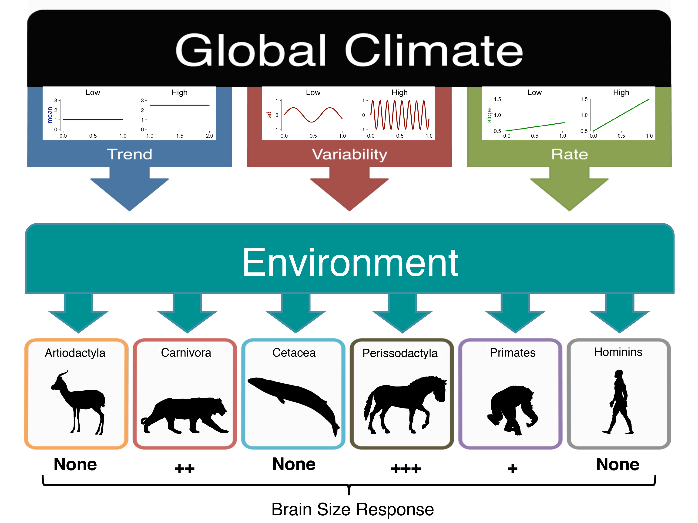

**Figure 1**. Multiple aspects of global climate change (Trend, Variability, and Rate of change) can simultaneously affect the environment. Cartoon examples of High and Low Trend, Variability, and Rate are shown within their respective climatic variable boxes. These changes in environment can alter the selective pressures acting on the organisms that inhabit it over an evolutionary timescale. Some taxa show a significant relationship between climatic variables (Trend, Variability, and/or Rate) and cranial capacity (CC), suggesting that some taxa have indirectly responded to changing global climate by evolving larger brains. After appropriately detrending the time-series data, it was found that Perissodactyla CC was the most frequently responsive (+++, Evidence Score=25.00), Carnivora CC was next most responsive (++, Evidence Score=12.50), and Primates CC was less responsive (+, Evidence Score=4.17). Artiodactyla, Cetacea, and hominins demonstrated no evidence of a relationship between brain size and global climate for any climatic variable at any tested time interval (1My, 400Ky, 200Ky).

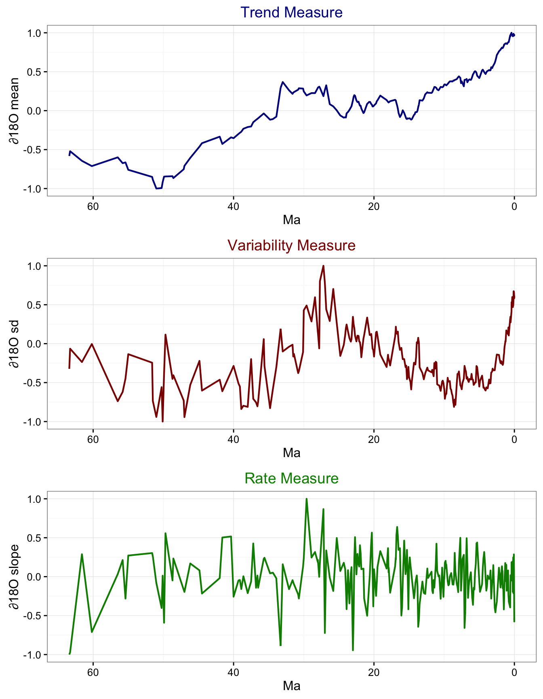

**Figure 2**. Multiple climatic measures of the oxygen isotope (∂18O) record over the last 65My. Measures were calculated by starting at the age (Ma) of a ∂18O data point, and encompassing all the ∂18O data in the prior 400Ky time interval (e.g. all ∂18O data within 10.2Ma–10.6Ma). This procedure was repeated over all data points in the ∂18O record. Trend was quantified as the ∂18O mean within a time interval, Variability was quantified as the standard deviation (sd) within a time interval, and Rate was quantified as the slope of the ordinary least squares (OLS) regression within a time interval. Some climatic variables display long-term directional changes over time, for example the pattern of increasing Trend (higher mean ∂18O) over the last ~50My, or the pattern of increasing Variability (higher sd) over the last ~10My. If another time-series dataset, CC for example, also shows a pattern of change over time, these climatic variables and CC may cross-correlate despite being causally unrelated. Detrending time-series data such as these can help guard against such spurious cross-correlations and reveal true relationships.

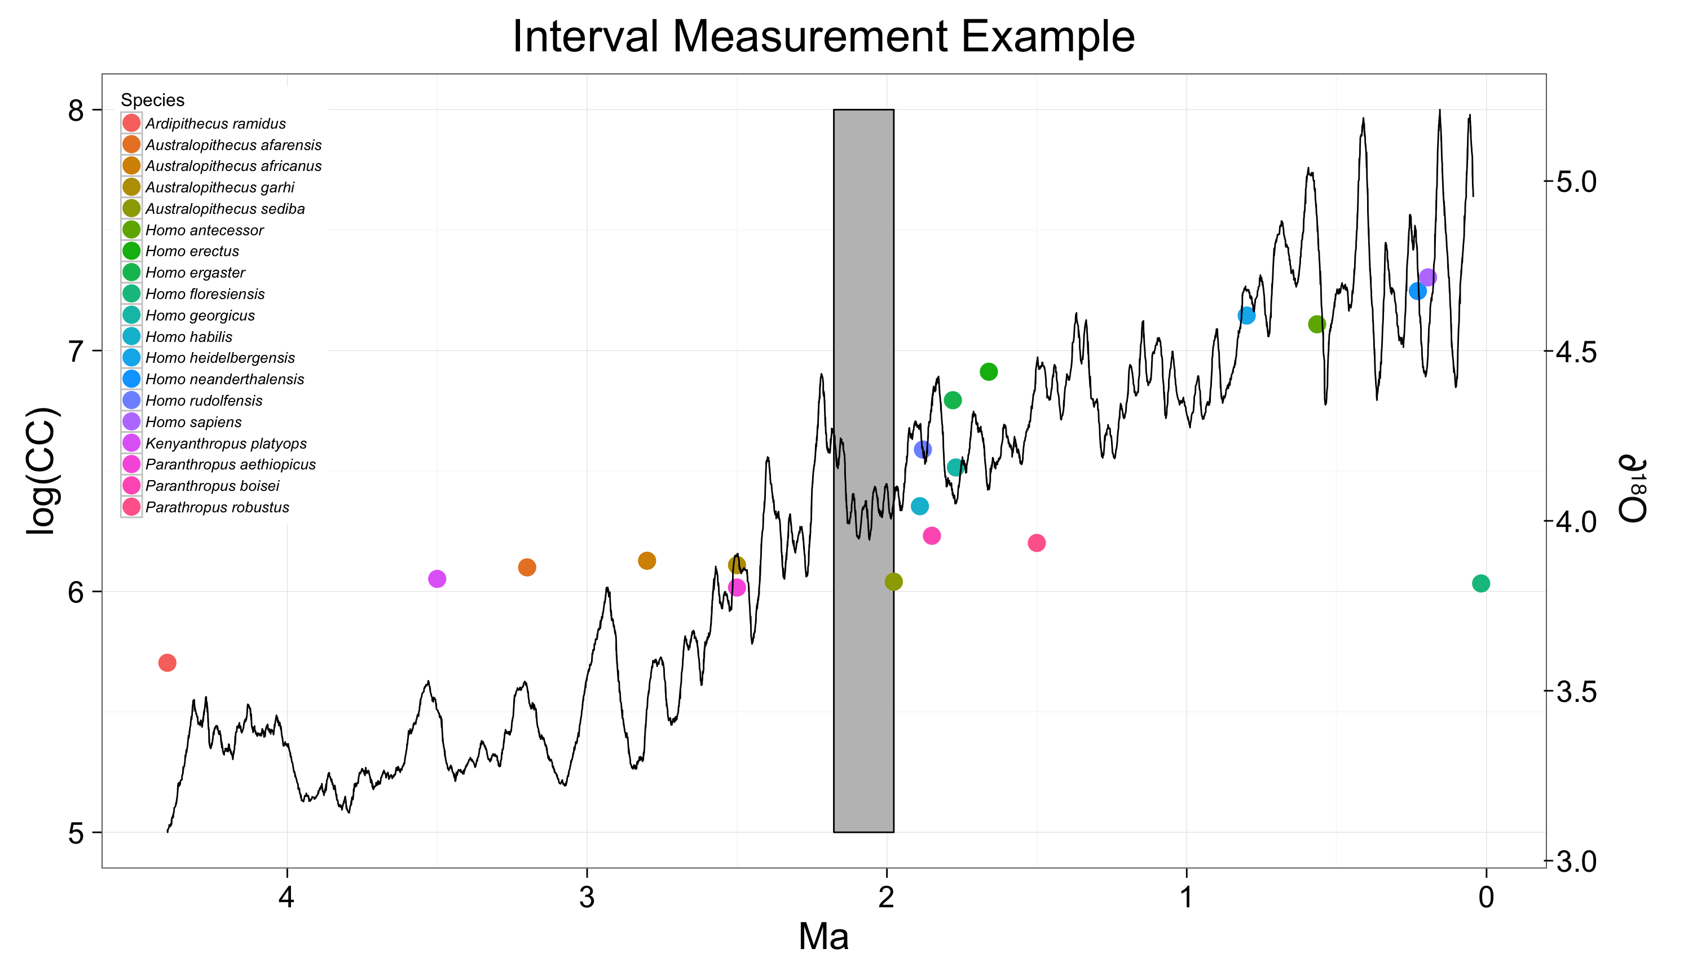

**Figure 3**. Example of how measures of the oxygen isotope record (black line, ∂18O on right y-axis) were collected from the time intervals preceding the first appearance datum (FAD) associated with a species (either fossil or ancestral reconstructed). Each point is a species averaged fossil cranial capacity (points, log scale CC on left y-axis). In this example, the 200Ky interval preceding the 3.2Ma FAD of *Australopithecus sediba* is enclosed within the grey rectangle, spanning the time period 3.2–3.4Ma.

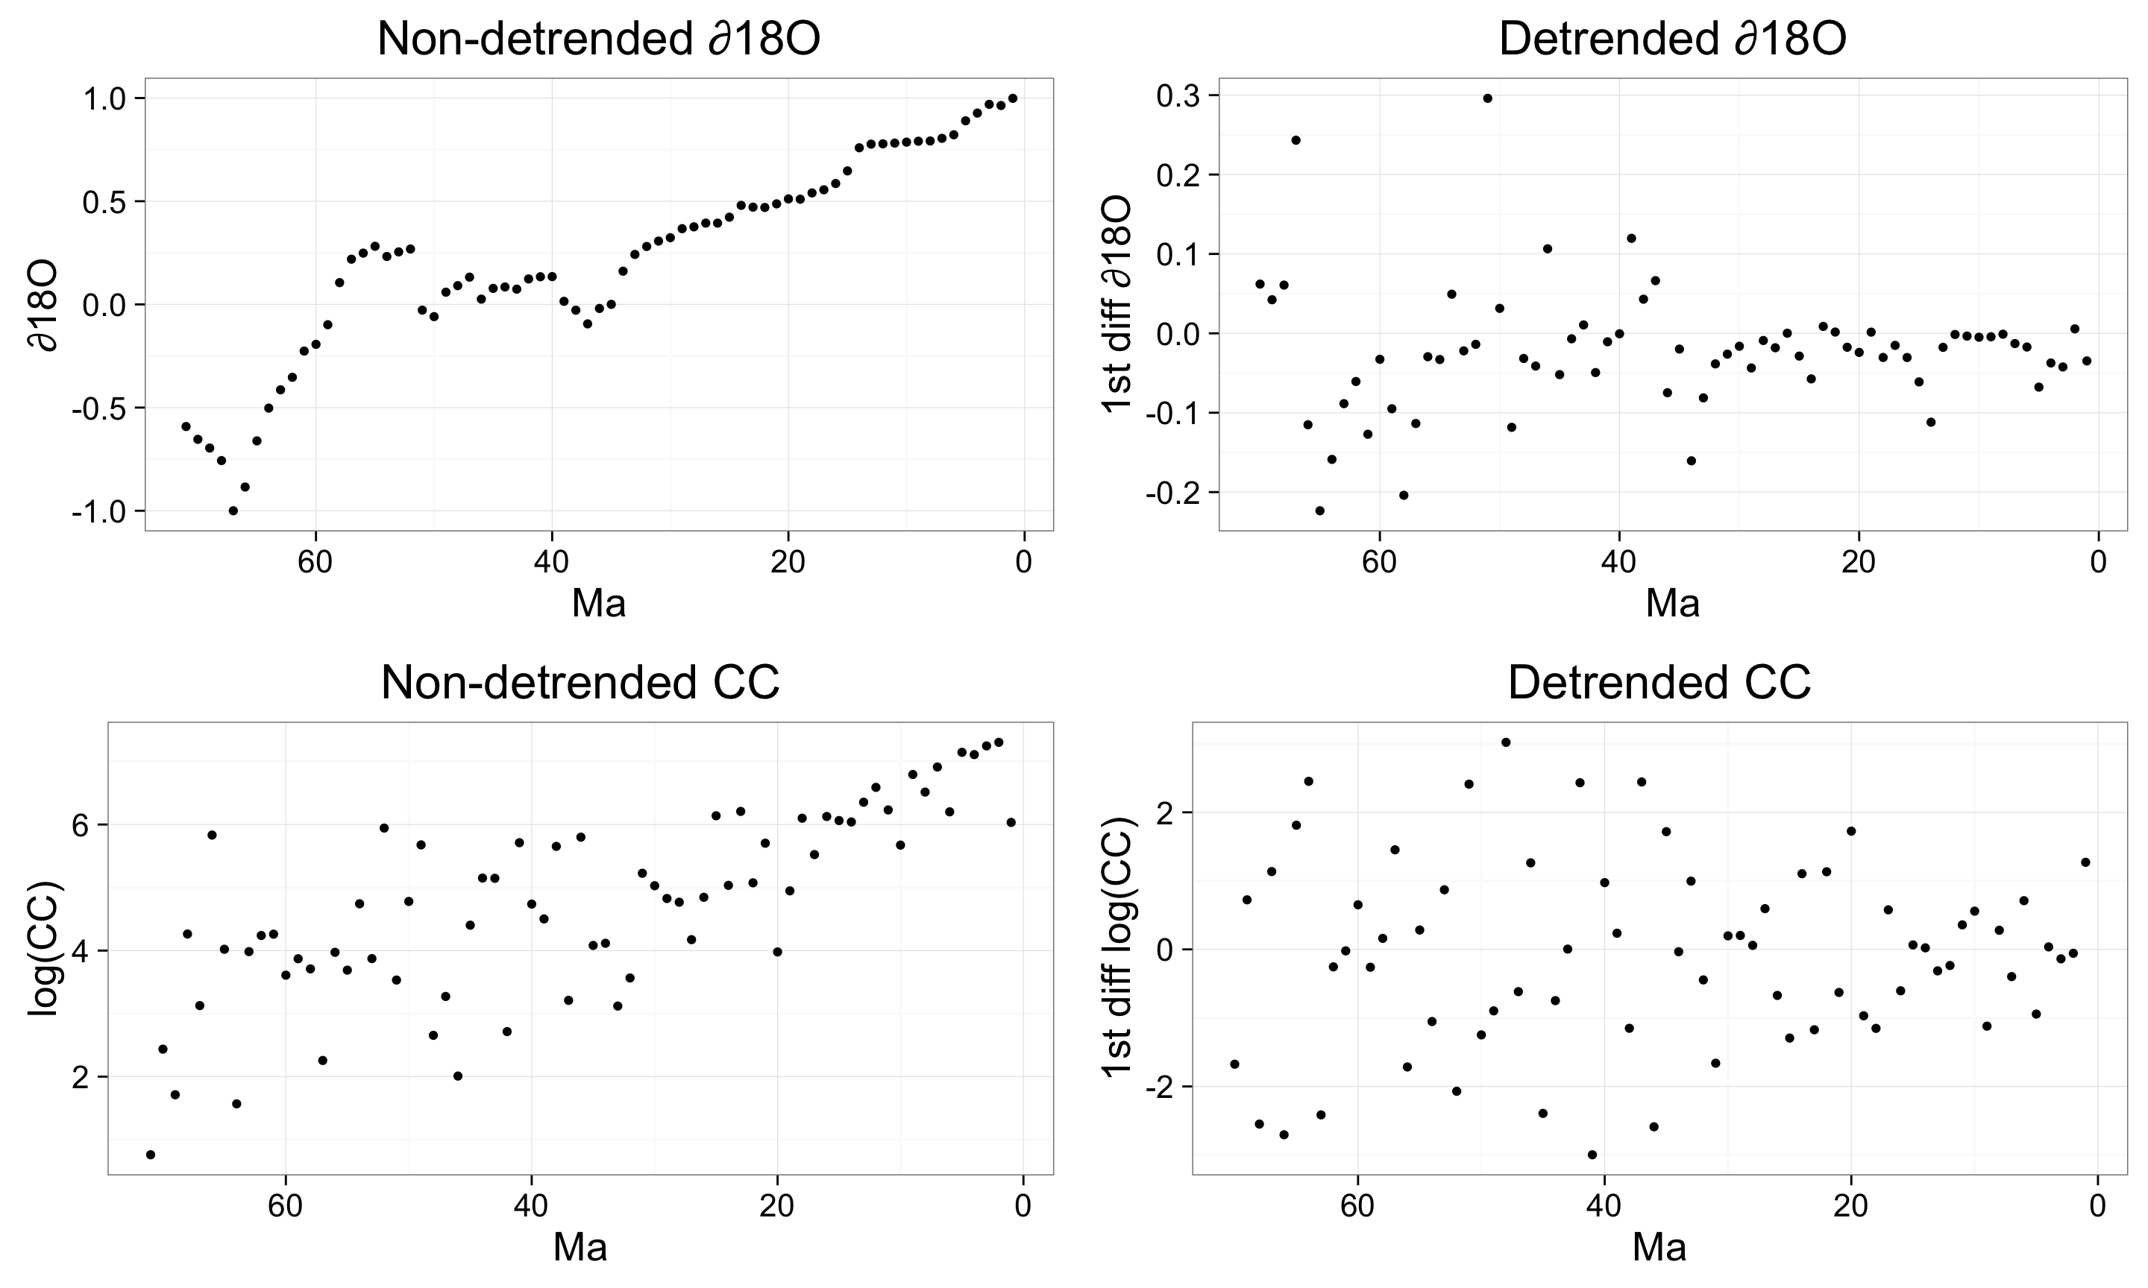

**Figure 4**. Demonstration of the effect of detrending time-series data (in this case the oxygen isotope record and mammalian CC over the last 65My) by calculating the first difference between temporally adjacent data points. The non-detrended oxygen isotope record (∂18O) indicates a clear trend toward global cooling over time (upper left). After detrending the data, we are left with the degree of ∂18O changes over many time points rather than the absolute value. Cranial capacity (CC) data (both fossil and ancestral reconstructed) similarly showed a trend when non-detrended (bottom left) that disappeared once detrended (bottom right).

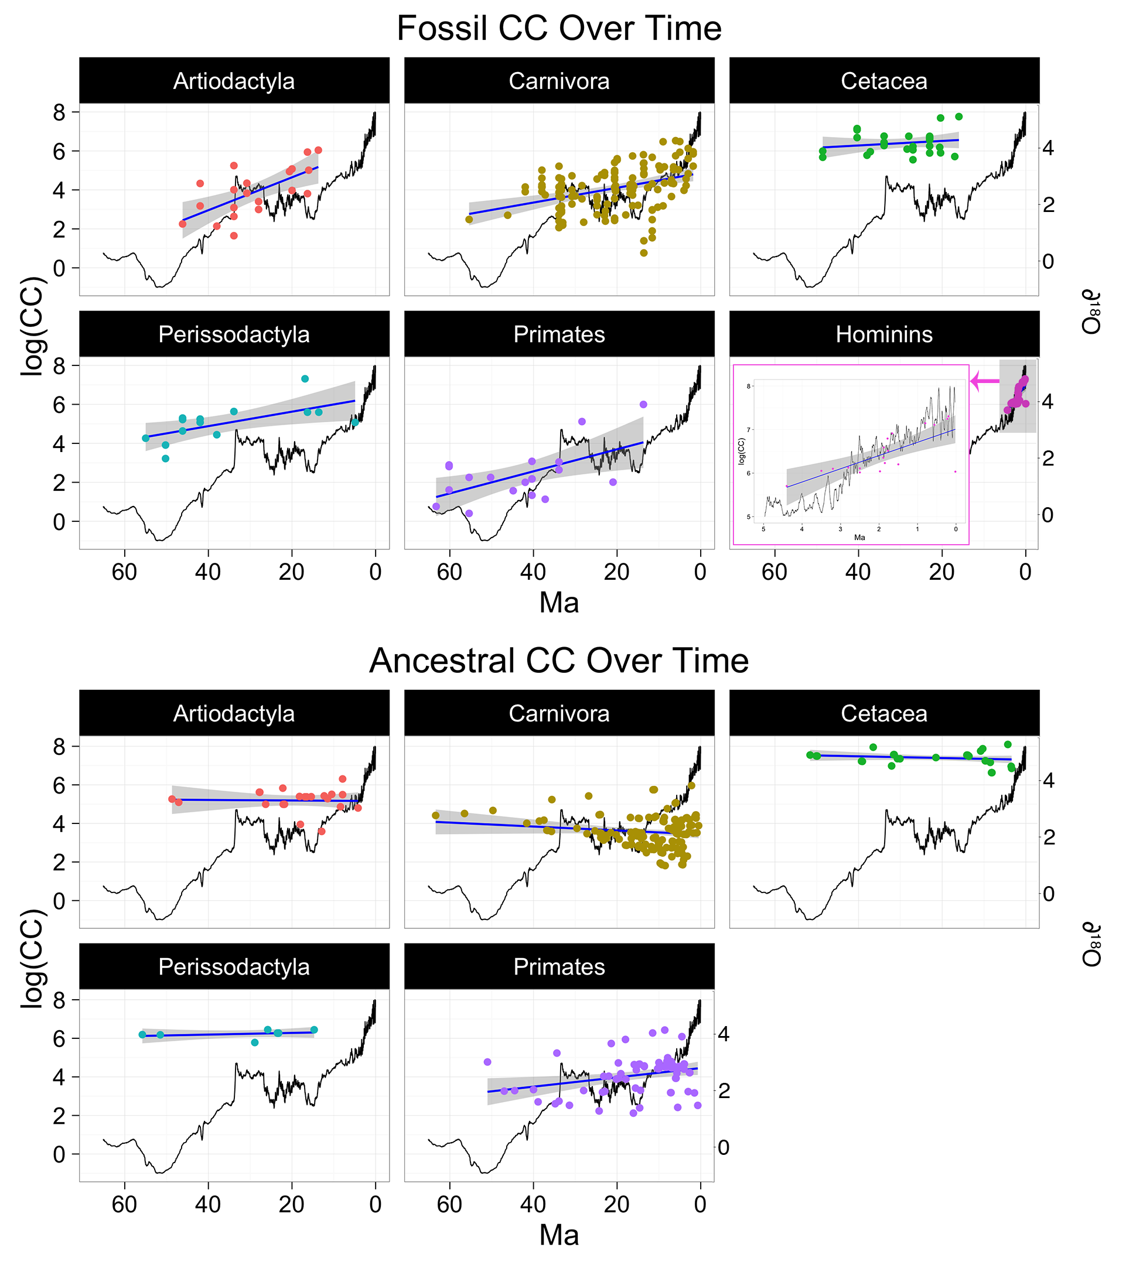

**Figure 5**. Fossil cranial capacity (CC) for six taxa (**A**) and ancestral reconstructed CC derived from five extant mammalian taxa over time (**B**) (points, logged scale on left y-axis) with corresponding best fit lines from ordinary least squares (OLS) regressions (blue line) with confidence intervals (grey shading). The ∂18O record over 65My is illustrated for each taxa (black line, scale on right y-axis). The hominin plot (A) was expanded for visualization purposes due to the relatively short period of time the hominin fossil record occupies.

Of the fossil taxa, each taxa showed evidence of increased CC over time (aR2 = 0.139–0.834, p < 0.05), except Cetacea (p > 0.05). Of the ancestral CC taxa, only Primates CC show a significant change of CC over time, which increased over time (aR2 = 0.074, p = 0.012) (see Tables S1 & S2 for full results).



**Table 1**. This table provides an overall summary of cranial capacity (CC) vs. climate analysis results. In Significance columns, “Y” denotes that there was a significant relationship found between CC and a given climatic variable, and/or the overall model, whereas “N” denote that no significant CC-climate relationship was found (p<0.05).

Concordance Scores are the percentage of fossil CC results that concurred with ancestral CC analyses matched for time interval (1My, 400ky, 200Ky) and climatic predictor variable (Trend, Variability, Rate), regardless of whether the data was non-detrended or detrended. Evidence Scores were calculated as the percentage of detrended results that showed evidence of CC-climate relationships (to the exclusion of non-detrended results due to confounds associated with temporal autocorrelation). Some taxa demonstrated evidence of CC-climate interactions (i.e. Carnivora, Perissodactyla, and Primates) while other taxa demonstrated no such evidence (i.e. Artiodactyla, Cetacea, and hominins).

**SUPPLEMENTARY MATERIALS**



**Table S1**. Results of linear regressions in which fossil cranial capacity (CC) was the response variable and time, in terms of millions of years ago (Ma), was the predictor variable. Negative estimate values mean that CC grew larger as we come closer to the present (Increase), positive estimate values mean CC grew smaller as we approach the present, and no significant means that there was no significant trend of CC in either direction (Stable).



**Table S2**. Results of linear regressions in which ancestral reconstructed cranial capacity (CC) was the response variable and time, in terms of millions of years ago (Ma), was the predictor variable. Negative estimate values mean that CC grew larger as we come closer to the present (Increase), positive estimate values mean CC grew smaller as we approach the present, and no significant means that there was no significant trend of CC in either direction (Stable).



**Table S3.** Results of multiple regression analyses in which fossil cranial capacity (CC) was the response variable and climatic measures (mean, SD, and slope of the ∂18O curve) were the predictor variables. Analyses were first conducted with all taxa grouped together, and then divided into respective taxa. Hominins were also subdivided into individuals (“Individualized hominins”). Highlighted p values are significant at <0.05. This time-series data was first analyzed non-detrended (A) and then detrended (B).



**Table S4.** Results of multiple regression analyses in which ancestral reconstructed cranial capacity (CC) was the response variable and climatic measures (mean, SD, and slope of the ∂18O curve) were the predictor variables. Analyses were first conducted with all taxa grouped together, and then divided into respective taxa. Highlighted p values are significant at <0.05. This time-series data was first analyzed non-detrended (A) and then detrended (B).